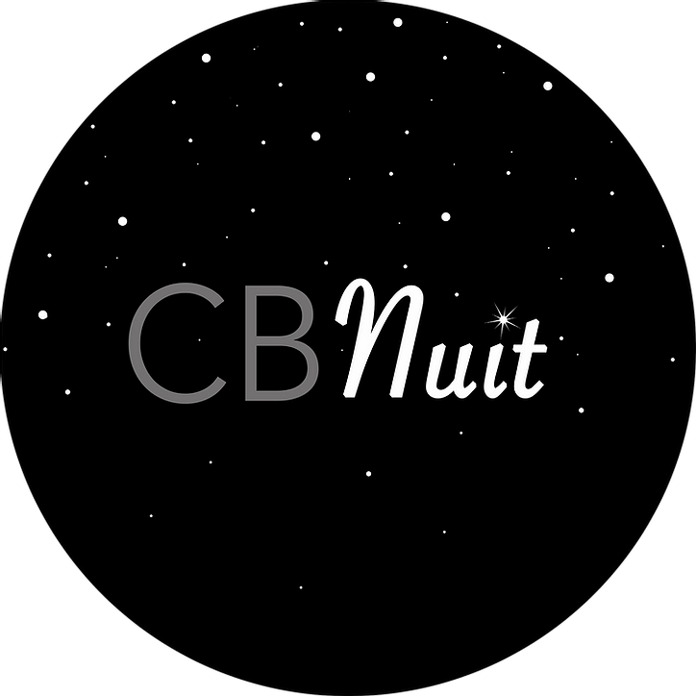

CB NUIT 2021 | COMMUNITY PROJECT | Application Form
DEADLINE FOR SUBMISSION: May 21st, 2021
SUBMIT TO: Email address: cbnuit@gmail.com with subject line COMMUNITY PROJECT 2021

Applicant(s) or collective name
Applicant(s) pronouns

Project Title

Short statement/bio describing your journey as a creative/maker (max 200 words):

A project description which highlights the inspiration, creation process and vision of your project. (max 450 words)

Technical details or any specific needs or concerns:

A Support Material list that includes 5-10 images or links to video/sound work. *Include title, and a detailed description if necessary (style, medium, year) and please ensure attached images are numbered accordingly to your support material list and include your name (01YourName.jpg)
1.

2.

3.

4.

5.

6.

7.

8.

9.

10.

*Support material Requirements:
• Images in JPEG format
•Video and sound support material should be included as links to Vimeo, Youtube or Soundcloud. (max 5 mins each)
- Large files can be sent via WeTransfer
- Text files should be sent as PDFs.

A Project Material List

A scheduled opportunity for the community to drop in and contribute to the project or help with assembly/production elements. (the CB Nuit team will help create the schedule for school visits and connect with teachers in the area)

*All applicants will be contacted by mid-June and feedback will be available upon request.

